CS 6375

ASSIGNMENT _____6_______

Names of students in your group:

Mansi Kukreja(mxk174330)

Deepan Verma(dxv160430)

Number of free late days used: ________0___________   
Note: You are allowed a **total** of 4 free late days for the **entire semester**. You can use at most 2 for each assignment. After that, there will be a penalty of 10% for each late day.

Please list clearly all the sources/references that you have used in this assignment.

**CLUSTERED IMAGE 1**

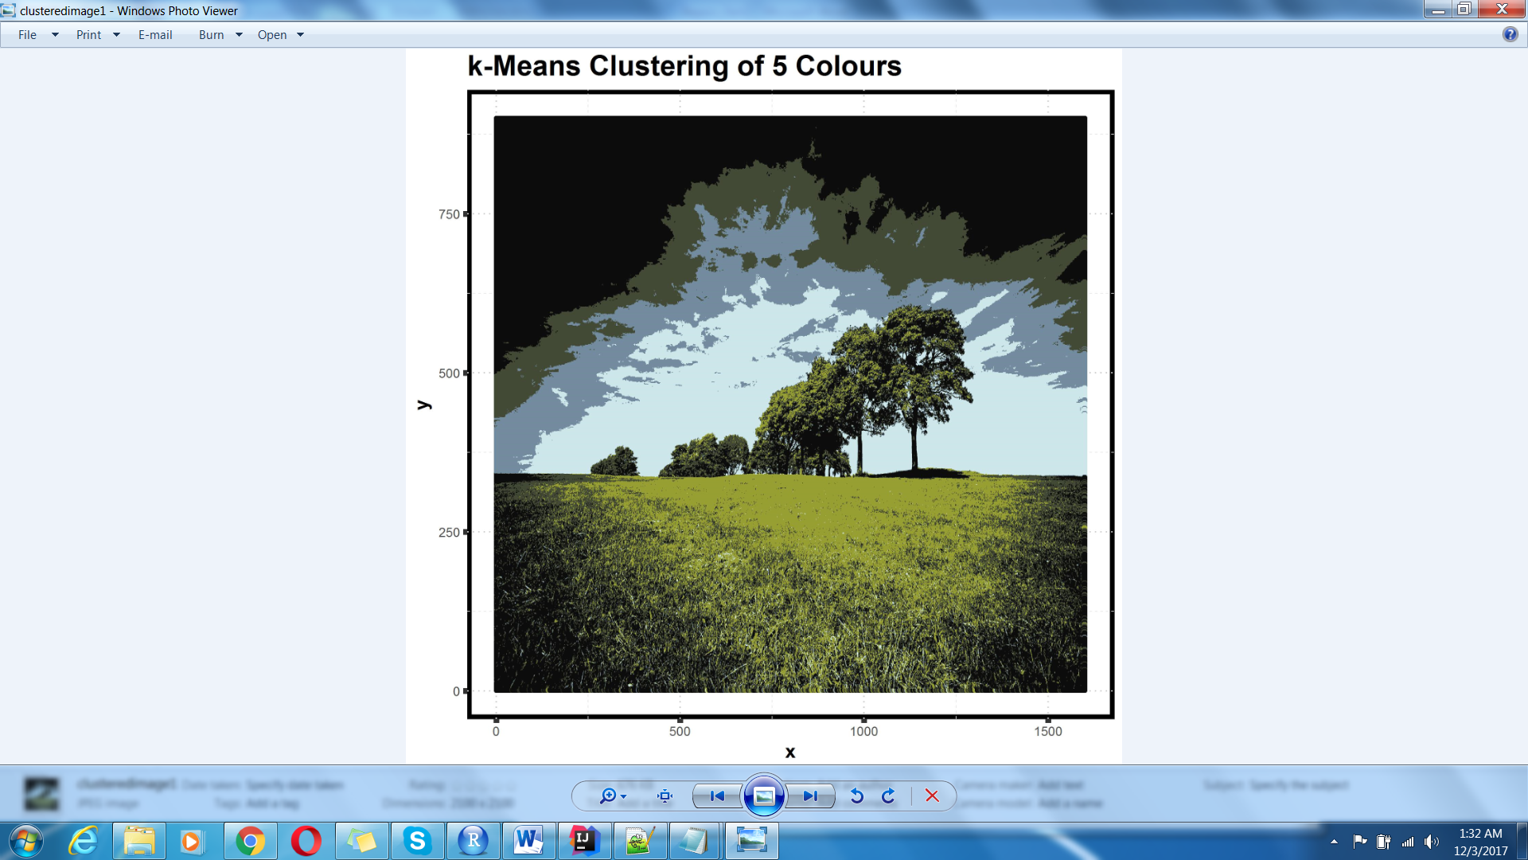

**CLUSTERED IMAGE 2**

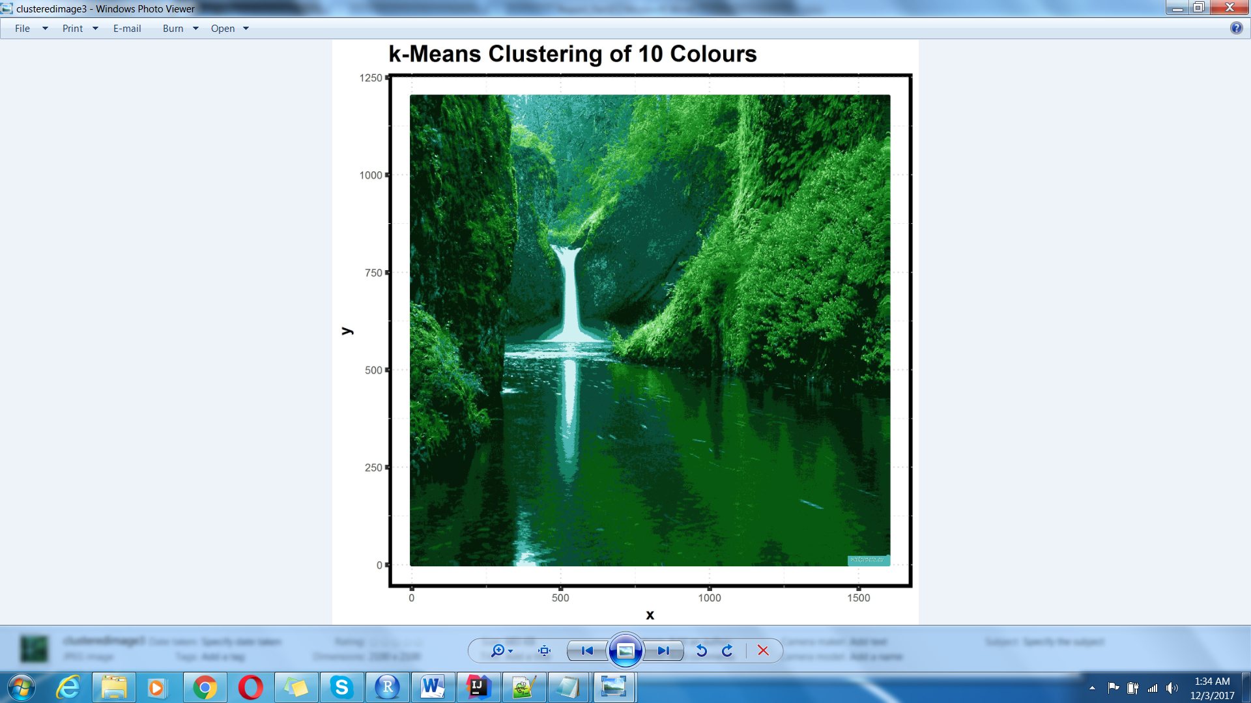

**CLUSTERED IMAGE 3**

